Menu Velocity Monitoring
--------------------------------------------------
Select Merchant
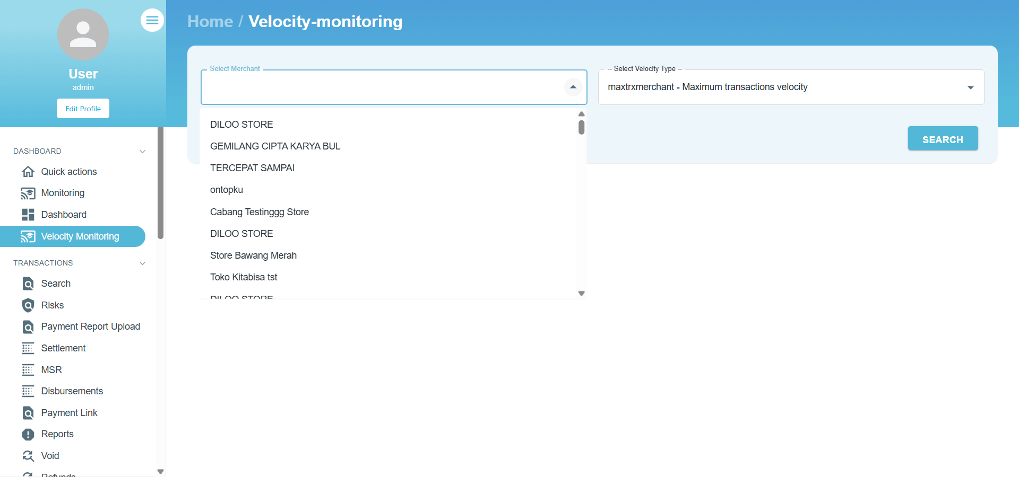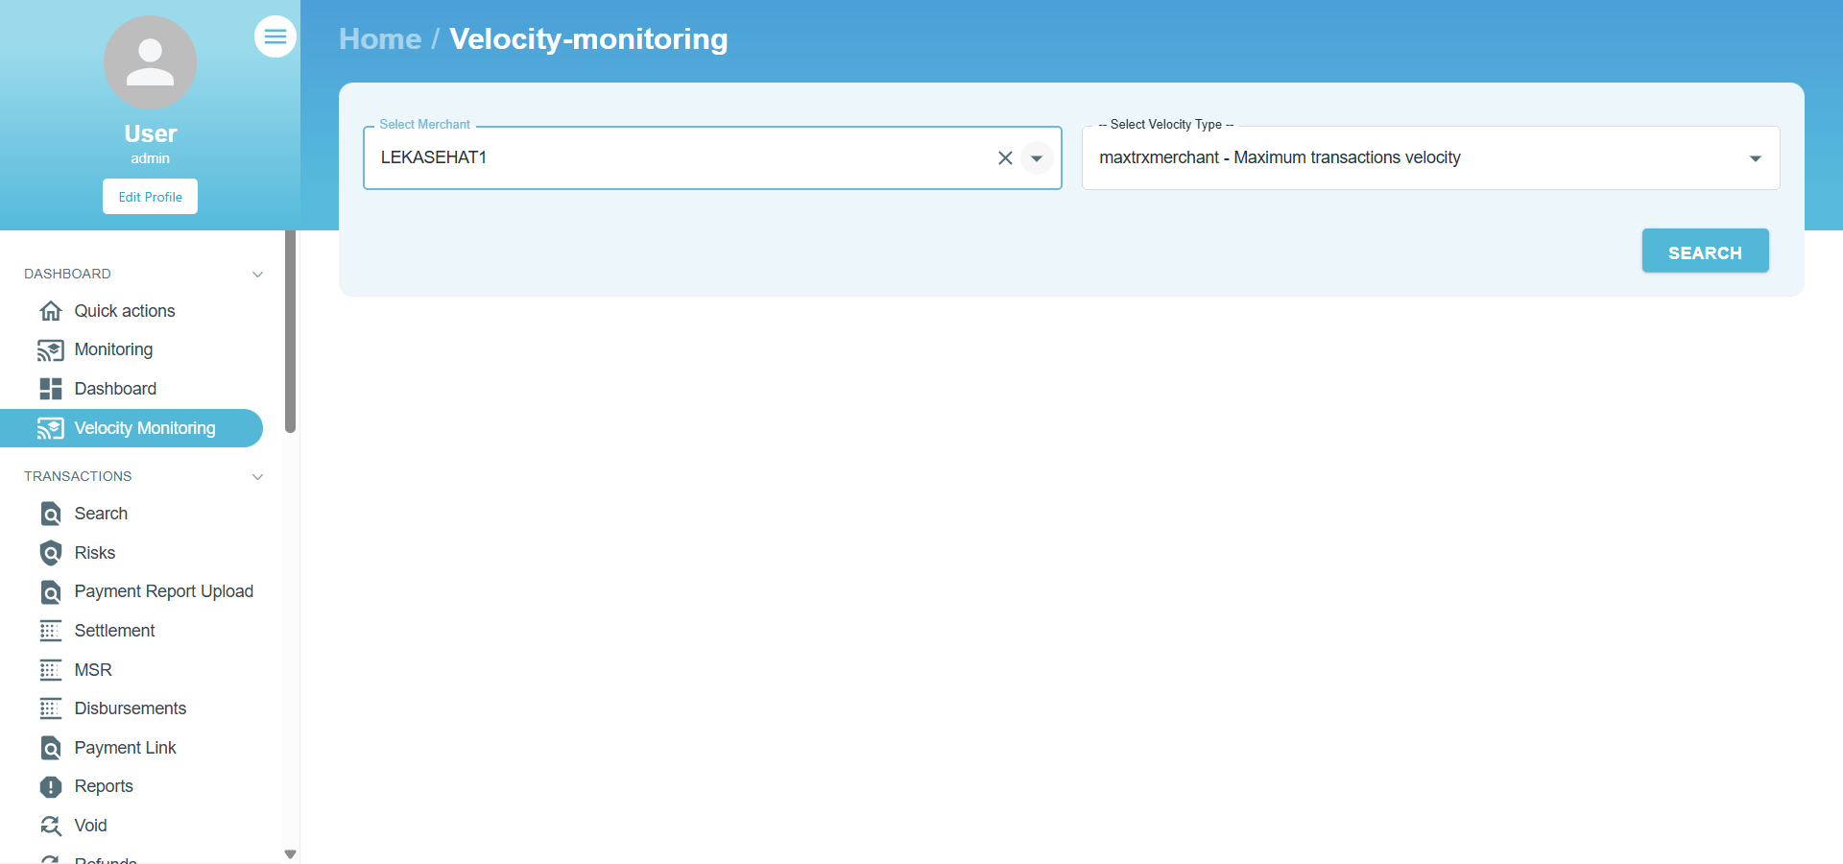
Select Velocity Type
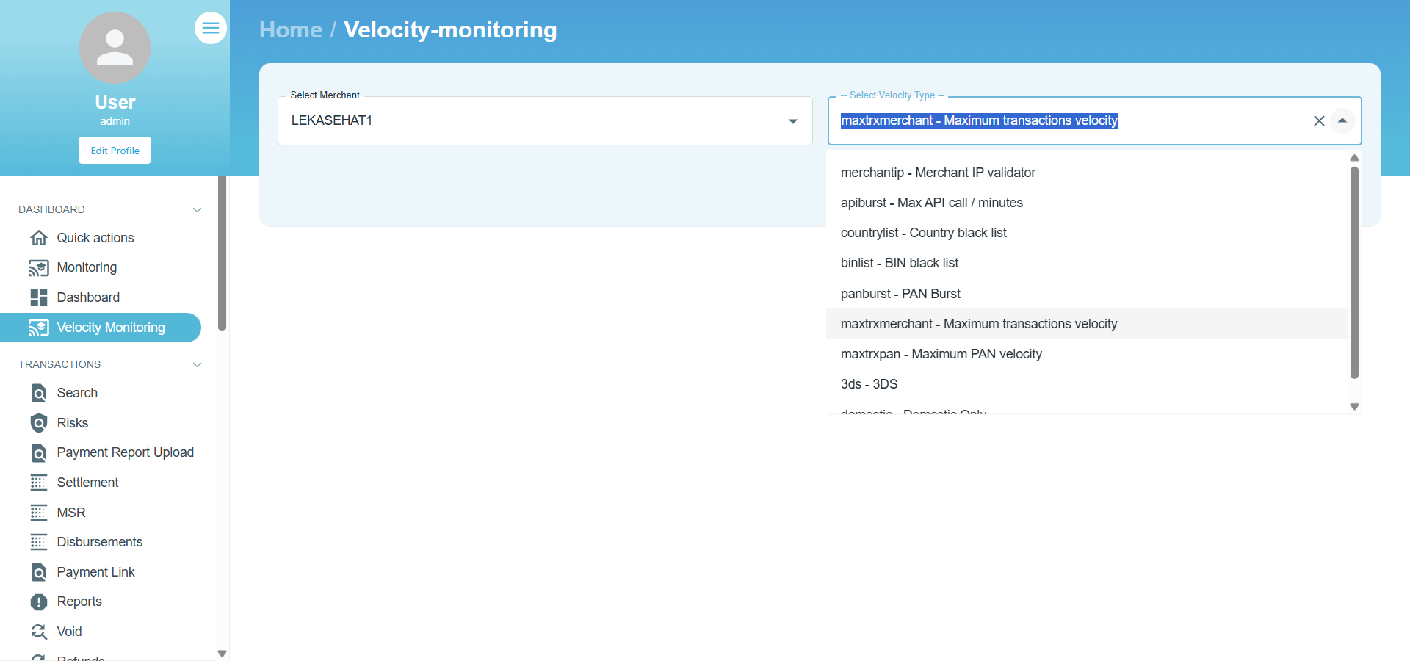
Search Velocity Type - Merchant Tip
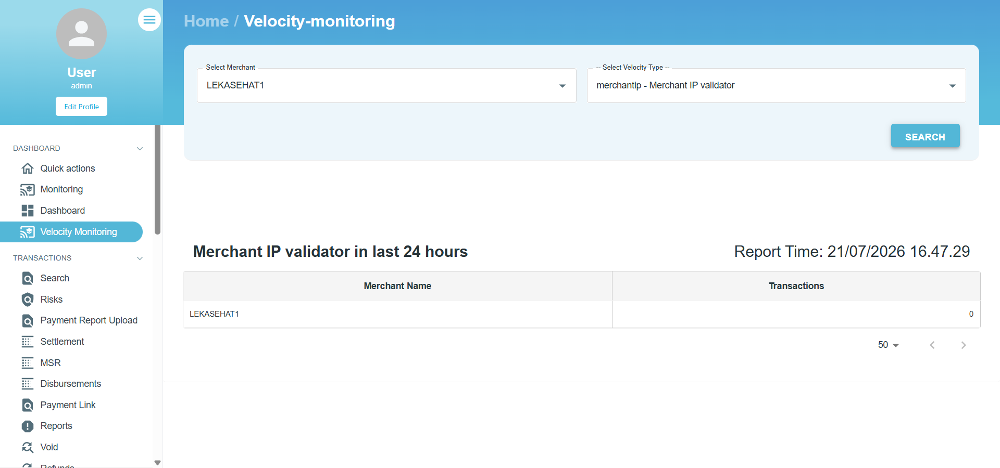
Search Velocity Type - Apiburst
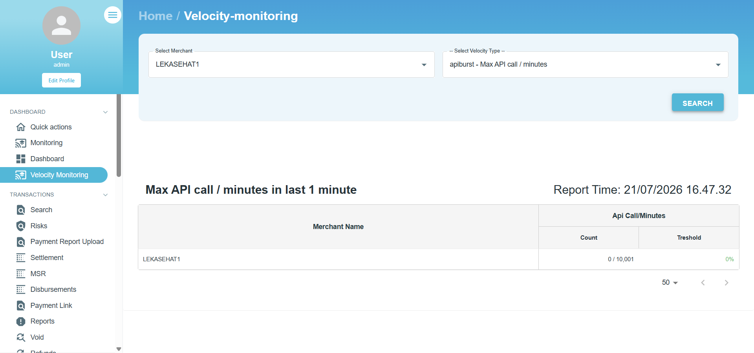
Search Velocity Type - Countrylist
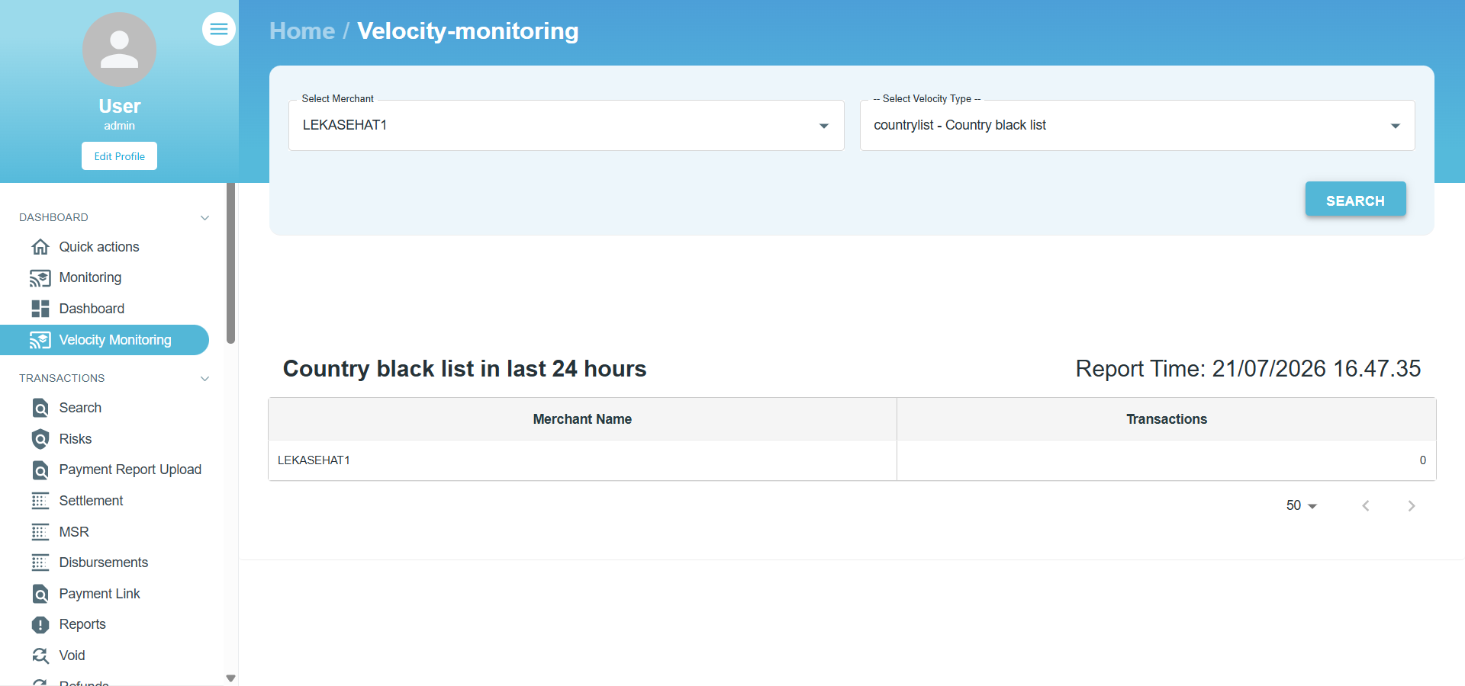
Search Velocity Type - Binlist
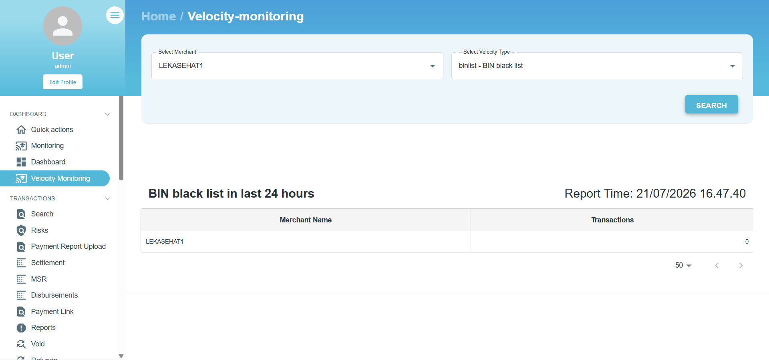
Search Velocity Type - Panburst
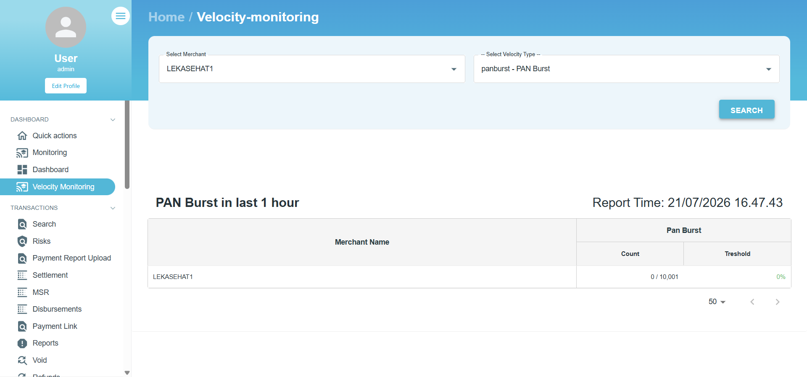
Search Velocity Type - Maxtrxmerchant
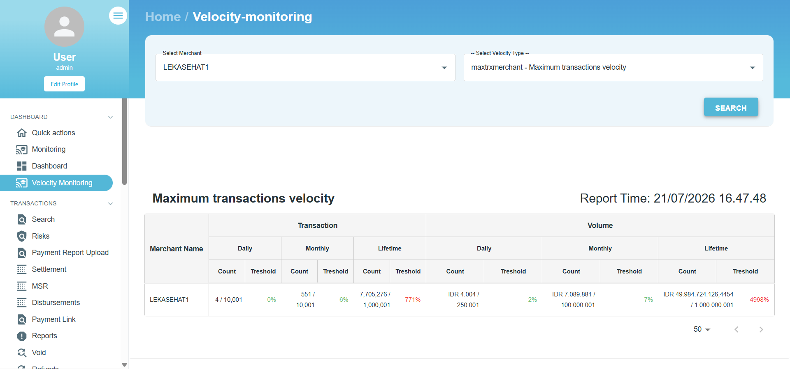
Search Velocity Type - Maxtrxpan
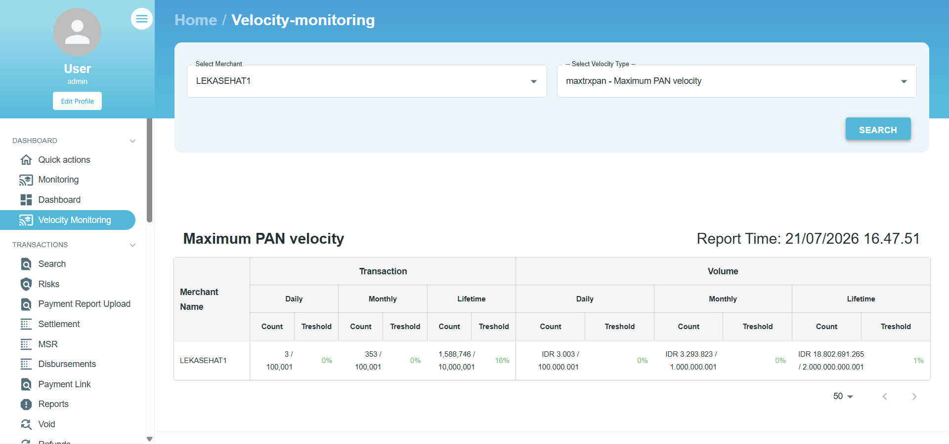
Search Velocity Type - 3ds
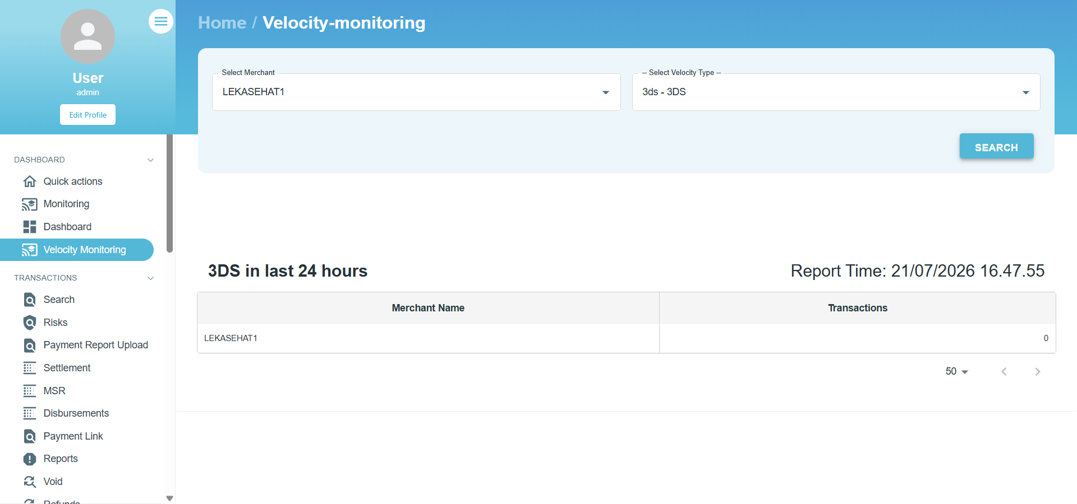
Search Velocity Type - Domestic
